# CS 255 Business Requirements Document Template

Complete this template by replacing the bracketed text with the relevant information.

This template lays out all the different sections that you need to complete for Project One. Each section has guiding questions to prompt your thinking. These questions are meant to guide your initial responses to each area. You are encouraged to go beyond these questions using what you have learned in your readings. You will need to continually reference the interview transcript as you work to make sure that you are addressing your client’s needs. There is no required length for the final document. Instead, the goal is to complete each section based on your client’s needs.

**Tip:** You should respond in a bulleted list for each section. This will make your thoughts easier to reference when you move into the design phase for Project Two. One starter bullet has been provided for you in each section, but you will need to add more.

## System Components and Design

### Purpose

*What is the purpose of this project? Who is the client and what do they want their system to be able to do?*

* ***The purpose of this project is to develop a comprehensive training and testing platform for DriverPass.***
* ***The client is DriverPass, and they want their system to provide online practice exams and facilitate on-the-road training for driving students.***

### System Background

*What does DriverPass want the system to do? What is the problem they want to fix? What are the different components needed for this system?*

* ***DriverPass wants the system to offer a user-friendly interface for students to access practice exams and schedule training sessions.***
* ***The problem they want to fix is the lack of an integrated platform that combines theoretical knowledge assessment with practical driving training.***
* ***The different components needed for this system include a practice exam module, scheduling functionality, user accounts for students and instructors, and performance analytics.***

### Objectives and Goals

*What should this system be able to do when it is completed? What measurable tasks need to be included in the system design to achieve this?*

* **The system should be able to provide a seamless experience for students to prepare for their driving tests and track their progress.**
* **Measurable tasks to include in the system design are the ability to complete a set number of practice exams, schedule and attend a defined number of training sessions, and receive feedback on performance.**

## Requirements

### Nonfunctional Requirements

*In this section, you will detail the different nonfunctional requirements for the DriverPass system. You will need to think about the different things that the system needs to function properly.*

***- The system needs to be user-friendly and accessible on both desktop and mobile devices.***

***- It should ensure data security and privacy for all user information.***

***- The system must have a responsive design to accommodate various screen sizes.***

#### Performance Requirements

*What environments (web-based, application, etc.) does this system need to run in? How fast should the system run? How often should the system be updated?*

* ***The system should run in a web-based environment, allowing access from any device with internet connectivity.***
* ***It should load pages within 2 seconds for optimal user experience.***
* ***The system should be updated regularly, at least once a month, to include new exam questions and features.***

#### Platform Constraints

*What platforms (Windows, Unix, etc.) should the system run on? Does the back end require any tools, such as a database, to support this application?*

* ***The system should be compatible with major platforms, including Windows, macOS, and mobile operating systems like iOS and Android.***
* ***The back end will require a robust database to store user data, exam results, and training schedules, likely utilizing SQL or similar technologies.***

#### Accuracy and Precision

*How will you distinguish between different users?* *Is the input case-sensitive? When should the system inform the admin of a problem?*

* ***To distinguish between different users, the system will assign unique identifiers to each user, such as usernames or email addresses. The input will be case-sensitive, meaning that "User" and "user" would be treated as different entries. The system should inform the admin of a problem when there are multiple failed login attempts from the same user, indicating a potential security threat.***

#### Adaptability

*Can you make changes to the user (add/remove/modify) without changing code? How will the system adapt to platform updates? What type of access does the IT admin need?*

* ***Yes, changes to user information can be made without altering the code, typically through an admin dashboard. The system should be designed to adapt to platform updates by utilizing modular architecture and maintaining compatibility with updated libraries and frameworks. The IT admin will need access to the backend management system to perform these changes and updates.***

#### Security

*What is required for the user to log in? How can you secure the connection or the data exchange between the client and the server? What should happen to the account if there is a “brute force” hacking attempt? What happens if the user forgets their password?*

* ***To log in, users will need a valid username and password combination. Securing the connection can be achieved through SSL/TLS encryption to protect data exchange between the client and server. In the event of a "brute force" hacking attempt, the account should be temporarily locked after a set number of failed login attempts. If a user forgets their password, they should be able to initiate a password reset process through a secure email link.***

### Functional Requirements

*Using the information from the scenario, think about the different functions the system needs to provide. Each of your bullets should start with “The system shall . . .” For example, one functional requirement might be, “The system shall validate user credentials when logging in.”*

* ***The system shall validate user credentials when logging in.***
* ***The system shall allow users to create and manage their profiles.***
* ***The system shall provide practice exams with instant feedback on performance.***
* ***The system shall enable users to schedule and manage training sessions.***
* ***The system shall generate performance analytics for users and instructors.***

### User Interface

*What are the needs of the interface? Who are the different users for this interface? What will each user need to be able to do through the interface? How will the user interact with the interface (mobile, browser, etc.)?*

***The interface needs to be intuitive and user-friendly for various users, including students and instructors. Students will need to access practice exams, view their progress, and schedule training sessions. Instructors will need to manage training schedules and provide feedback. Users will interact with the interface through both mobile devices and web browsers, ensuring accessibility across platforms.***

### Assumptions

*What things were not specifically addressed in your design above? What assumptions are you making in your design about the users or the technology they have?*

* ***Some assumptions in the design include that users have basic digital literacy and access to the internet. It is also assumed that the technology used will remain stable and supported during the system's lifespan.***

### Limitations

*Any system you build will naturally have limitations. What limitations do you see in your system design? What limitations do you have as far as resources, time, budget, or technology?*

* ***Limitations in the system design may include potential challenges in scalability as the user base grows. Additionally, there may be constraints regarding budget, time, and available technological resources, which could impact the features implemented in the initial version of the system.***

### Gantt Chart

*Please include a screenshot of the GANTT chart that you created with Lucidchart. Be sure to check that it meets the plan described by the characters in the interview.*

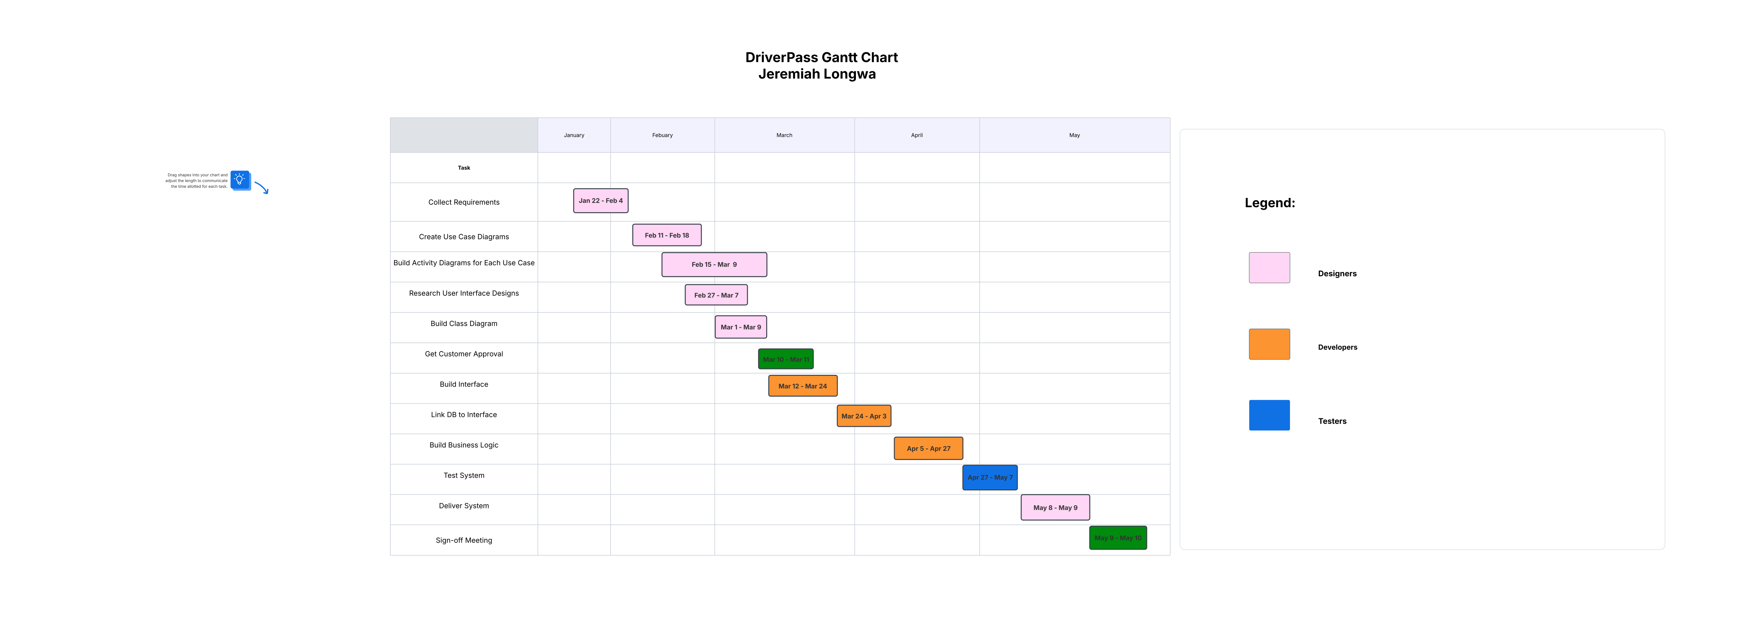

Caption